## 8.Sudomu *

Write a function that implements **SUDOMU** (**Sudoku inside the DOM**).



The rules are simple and they are **the same** as the **typical sudoku game** (for more information, click [here](https://sudoku.com/how-to-play/sudoku-rules-for-complete%20beginners/)).

If the table is filled with the **right numbers**, and the ["Quick Check"] button is **clicked**, the expected result should

be:  
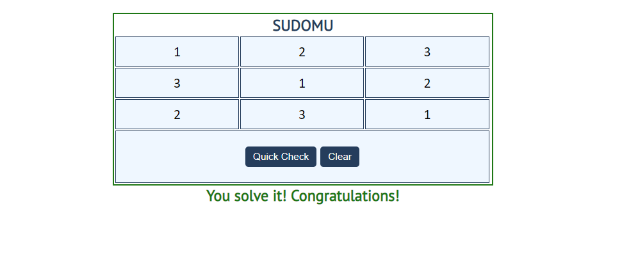

The table borer should be changed to: "2px solid green**".** The text content of the paragraph

inside the div with an **id** "check" must be "You solve it! Congratulations!"

The text color of that paragraph must be **green.**

Otherwise, when the filled table **does not solve** **the sudomu,** the result should be:

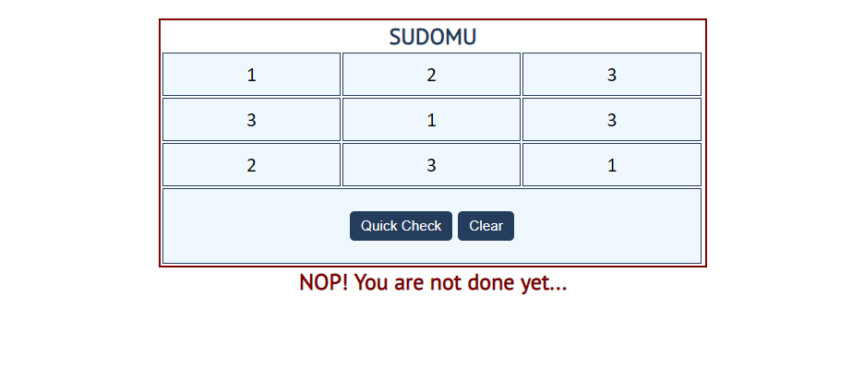

The table border should be changed to: "2px solid red". The text content of the paragraphinside the div

with an **id** "check" must be: "NOP! You are not done yet..."

The text color of thatparagraph must be **red!**

The["Clear"]button **clears the whole** **SUDOMU (removes all numbers)** and the **paragraph**

**which contains the messages. It also removes the table border.**

